

­

EDITION ONE

Company Profile

**Nexus Resources Development Ltd (NRD)**

2025

**Address:**

**Rajanighandha Tower (3rd Floor),**

**Section-10, Kochukhet, Dhaka-1206,**

**Email: road2nrdltd@gmail.com**

**Contact: +8801912161600, 8801706311480,**

**Web: www.nrd.org.bd**

**Contents**

Contents

1. Company Overview 3

2. Introduction and background 4

3. Key services offered by NRD: 4

4. Vision 4

5. Mission 4

6. NRD Values 4

7. NRD Objectives 5

8. Physical Facilities and Logistics 5

9. Managerial and Financial Management Capacity 9

10. Manpower/Human Resources 9

11. Scope of Working Areas 9

12. Plan of Action 11

13. Project Portfolio 12

14. Key Legal documents 16

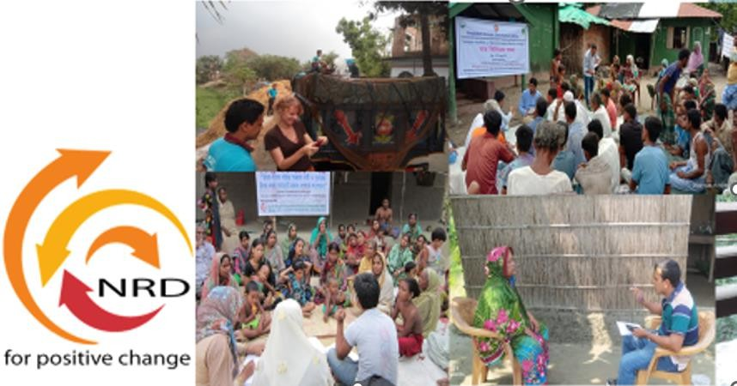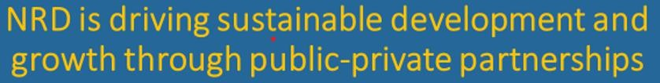



# Company Overview

|  |  |
| --- | --- |
| Legal Name | **Nexus Resources Development (NRD) Limited** |
| Years of Establishment and Company Formation | 2008,  2021 under Company Act XVIII OF 1994 |
| Country of Registration | Bangladesh |
| Type of Legal Entity | 1. Joint Stock Companies & Firms, Bangladesh, Registration No. C- 176006/2021. Dated: 08 November, 2021 2. Registered firm of the Dhaka City Corporation with Registration No. 03-079049. Dated. 22 January 2018 3. Registered firm of the Dhaka City Corporation with Registration No. 188313. Dated. 25 January 2022. 4. Registered under local government division from the Manda- 6510, Naogaon, dated: 06 July 2023. |
| Country of Registration | Bangladesh |
| Name of the contact  Person | Mst. Rumana Sharmin, Chairperson, Cell +8801916537887  +8801706311480 (office), Email: road2nrdltd@gmail.com, |
| Office | Rajanighandha Tower (3rd Floor), Section-10, Kochukhet, Dhaka-1206,  Contact: +88 01912 161600, +8801706311480  E: [road2nrdltd@gmail.com](mailto:road2nrdltd@gmail.com), [www.nrd.org.bd](http://www.nrd.org.bd) |
| Key area of Expertise | Feasibility study, Social Impact Studies, Environmental Impact Studies, Preparation of Land Acquisition Plan (LAP), Preparation of Resettlement Action Plan (RAP), Implementation and monitoring of LAP and RAP, GIS mapping, Traffic Survey, Topographic survey, Training and Capacity Development, Gender planning and Implementation, Income Livelihood Restoration Planning and Implementation, Human Resources Development, construction &  other resources management, IT, Agricultural and Infrastructure Development. |

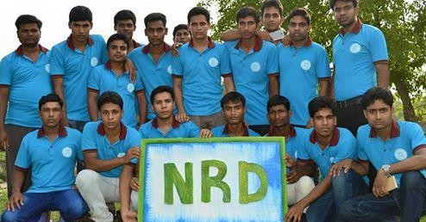

3

# Introduction and background

Nexus Resources Development Limited (NRD) is a multi-disciplinary research, development, and consulting company duly registered under the Register of Joint Stock Companies and Farms, People’s Republic of Bangladesh. It is also a registered firm of the Dhaka City Corporation and the local government division. NRD’s programs are aligned with the Sustainable Development Goals (SDGs) of the United Nations for a better world. NRD supports the government’s existing plan and operations from the grassroots to the national level in a sustainable way. NRD provides development services, takes initiatives, and implements projects in multi-sectoral fields in the context of Bangladesh and beyond

# Key services offered by NRD:

* + Policy and decision-making support



* + Preparation of Safeguard Documents
  + Social Impact Assessment (SIA)
  + Resettlement Planning and Implementation
  + Environmental Impact Assessment (EIA)
  + Census, Socio-economic studies
  + Initial Poverty & Social Assessment
  + Land Acquisition Planning and Implementation
  + Topographic Survey and Geo-referencing
  + Traffic and Transport Survey
  + M&E, MIS and Data Management
  + Livelihood Restoration Program
  + Auditing and Inventory Assessment & Evaluation
  + Infrastructure development

#### construction & other resources management

* + Human Resource Mobilization and Development

NRD involves reputed professionals, researchers, development experts, engineers, economists, anthropologists, sociologists, environmental and social safeguard specialists, renowned scholars and specialists on various field of development. NRD has been working in collaboration with some renowned Consulting Firms and Donor Agencies.

# Vision

Vision is to ensure sustainable development for everyone, everywhere, all the time.

# Mission

NRD’s mission is "for positive changes." We help people, partners, stakeholders, and clients realize their potential for sustainable development. Achieve meaningful goals and build quality of life through collective efforts.

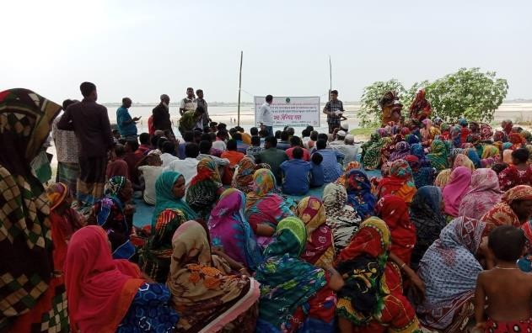

# NRD Values

* + Innovation and effectiveness
  + Accountability and transparency
  + Equality and participation
  + Dedication and compassion

# NRD Objectives

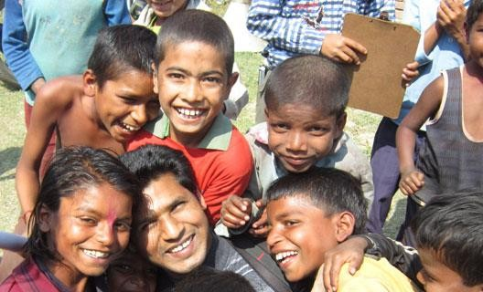

The long-term objectives of the organization include;

Our multi-disciplinary consulting company is committed to advancing integrated solutions that combine environmental sustainability, social equity, gender inclusivity, and resilient infrastructure. Our objectives include;

1. **Eco-Social Impact:** Conduct assessments,

prepare and implement environmental and social safeguard to ensure projects benefit the environment, society, and genders equally, promoting positive, lasting impacts.

1. **Inclusive Infrastructure:** Design infrastructure with accessibility, safety, and gender inclusivity at the core, enriching communities and fostering equality.
2. **Diversity Strategies:** Develop strategies that empower diverse talents, fostering innovation and equitable workplaces.
3. **Climate-Resilient Systems:** Create infrastructure that withstands climate challenges, ensuring enduring functionality and community protection.
4. **Sustainability Supply Chain:** Establish ethical supply chains that respect social fairness and environmental responsibility.
5. **Gender Empowerment & Inclusiveness:** Infuse gender-neutral design, disaggregation, safe spaces women and vulnerable groups, and indigenous people, promoting safety and security.
6. **Capacity Building and Training: Provide** capacity-building to drive sustainability, diversity, and gender equality in various domains.

We strive to be pioneers in holistic sustainability and inclusivity, guiding industries toward a harmonious future with these objectives.

# Physical Facilities and Logistics

#### NRD possesses a fully functional office (Head Office) at Dhaka, the capital city of Bangladesh and regional and district offices as well. NRD is well equipped with all facilities including necessary office equipment, modern computer, and communication system. NRD is quite capable of providing all essential logistics support to its head office as well as project offices as and when necessary.

#### Table: Essential Logistics Support

|  |  |  |  |
| --- | --- | --- | --- |
| Name of Items | No. | Name of Items | No. |
| Four-wheeler vehicle | 3 | Survey Equipment | 6 |
| Motor Cycle | 8 | Rain Coat | 15 |
| TAB | 50 | Umbrella | 50 |
| Drone | 1 | GPS | 15 |
| Printer | 3 | First Aid Kit | 1 |
| Scanner | 1 | IPS | 2 |
| Wireless Router | 2 | Intercom | 12 |
| Measurement equipment | 15 | Land measurement | 15 |
| Photocopier | 1 | Occupational safety  equipment | 50 |

|  |  |  |  |
| --- | --- | --- | --- |
| EQUIPMENT COMMISSIONING PARTNER | | | |
| **Sl.** | **NAME OF THE MACHINERY EQUIPMENT** | **QTY** | **PHOTOGRAPH** |
|  | 2000 Ton Crawler Crane | 01 |  |
|  | 1000 Ton Floating Crane | 01 |  |
|  | 800 Ton Crawler Crane | 01 |  |
|  | 600 Ton Floating Crane | 01 |  |
|  | Dump truck | 300 |  |
|  | 280 Ton Crawler Crane | 01 |  |
|  | 150 Ton Crawler Crane | 02 |  |
|  | 200 Ton Floating Crane | 01 |  |
|  | 115 Ton Tyre Crane | 01 |  |
|  | 100 Ton Crawler Crane | 03 |  |
|  | 100 Ton Tyre Crane | 02 |  |
|  | 80 Ton Crawler Crane | 01 |  |
|  | 70 Ton Crawler Crane | 01 |  |
|  | 60 Ton Hydraulic Crane | 01 |  |
|  | 25 Ton Hydraulic Crane | 02 |  |
|  | 20 Ton Hydraulic Crane | 02 |  |
|  | 10/12/15 Hydra Crane | 07 |  |
|  | 10 Ton Hydraulic Crane | 01 |  |
|  | Diesel Generator (600/316/260/250/160/115/110/100/30) KVA | 15 |  |
|  | 10 Ton Vibro Roller | 03 |  |
|  | DAF 450/550 HP (Prime Mover) | 02 |  |
|  | Mercedes 450/650 HP (Prime Mover) | 02 |  |
|  | 100 Ton Low Bed Trailer | 01 |  |
|  | 65 Ton King Low Loader Trailer | 01 |  |
|  | Wooden Planks | AMAR |  |
|  | Oil Testing Equipment | 02 |  |
|  | 40 Ton High Bed Trailer with Prime Mover | AMAR |  |
|  | 30 Ton High Bed Trailer | AMAR |  |
|  | Chain Dozer D-6 | 06 |  |
|  | 60 KW Vibro Hammer (electric) | 01 |  |
|  | 80 KW Vibro Hammer (electric) | 01 |  |
|  | 90 KW Vibro Hammer (electric) | 01 |  |
|  | Hydraulic Vibro Hammer with Power Pack (10 Ton) | 01 |  |
|  | SPMT (24 Axle) with 2 PRO | 01 |  |
|  | HMT (24 Axle) Single line | 01 |  |
|  | HMT 12 Axle for 1-1/2 Extra Width Cargo | 01 |  |
|  | Turbine Oil Centrifuging Machine | 01 |  |
|  | Transformer Oil Centrifuging Machine | 01 |  |
|  | Skate 100 Ton/ 200 Ton | 16 |  |
|  | Hydraulic Jack (50/100/200 Ton) | 50 |  |
|  | Excavator | 32 |  |
|  | 500 Ton Crawler Crane | 01 |  |
|  | Batching Plant | 3 |  |
|  | Asphalt Plant | 2 |  |
|  | Pay loader | 8 |  |
|  | Vibro Roller | 6 |  |
|  | Paver Machine | 2 |  |
|  | Distributor Machine | 3 |  |
|  | RCC Screed Vibrator | 2 |  |
|  | Grader | 3 |  |
|  | JCB | 4 |  |
|  | Bobcat | 3 |  |
|  | Supplier for Iron, Cement and Stone, and Sand filling |  | As required with B2B approaches |

# Managerial and Financial Management Capacity

NRD has managers in each section including operation, implementation, planning and management, finance and admin led by Managing Director.

# Manpower/Human Resources

NRD Professionals possess a high standard of education, vast experience, and are skilled in using modern technology to perform their responsibilities.

#### Professional, technical, and administrative staffs are working in NRD Headquarter and field offices. The composition of manpower and human resources of the organization is presented below: Table: The composition of manpower and human resources;

|  |  |
| --- | --- |
| Position | No. |
| Social Safeguard/ Social Development Expert | 8 |
| Land Acquisition / Resettlement Specialist | 6 |
| Legal Advisor | 4 |
| Land Surveyor | 8 |
| Traffic Engineer | 6 |
| Other Technical Staff | 15 |
| Field Staff or other construction worker | 52 |
| Support Staff | 6 |
| Total | 105 |

NRD very often engages professionals and experts specialized in various fields in different projects on a contractual basis. Hence, a list of experts and specialists is properly maintained by the administration of NRD to facilitate the recruitment of such people as and when required.

# Scope of Working Areas

|  |  |
| --- | --- |
| **Key working area** |  |
| ***Environmental and Social Assessment***   * Environmental and Social Baseline Study * Env. and Social Impact Assessment * Env. and Social Management Plan * Natural Resource Management * Nature and Pollution Control   Bio-diversity, ecology, agriculture, fisheries, livestock etc | ***Survey, Mapping, Design & Architect***   * Traffic Survey * Topographic Survey * GIS Mapping and Data Base * Subsoil Investigation * Design and architect * Infrastructure development. Climate change & Resilience |
| ***Safeguards, Compliance & Gender***  ***Inclusiveness***   * Prepare environmental & social safeguard * Prepare Tribal People Development Plan * Prepare HIV and Health Action Plan, COVID-19 response * Prepare Social and Envir. Compliance * Prepare Gender Action Plan, and gender mainstreaming * Promote empowerment * Conducted monitoring survey | ***External Monitoring of Safeguards***   * Review & verify safeguards * Land acquisition/resettlement * Evaluate & assess livelihood opportunities and incomes of Affected Person * Evaluate quality, sufficiency, and timeliness of delivering entitlements as per approved policy * Review suitability of relocation sites * Verify expenditure & adequacy of budget * Auditing, Integrity assessment |
| **Research, Baseline & Evaluation**   * Conduct baseline, midline, and end line * Action Research, * Market research * Value chain study * Conduct training activities * Program development and management | **Construction Work and Resource**  **Mobilization**   * Construction & worker support * Security service and protection * Safety, security, health hygiene * Electrical equipment management * Integrated Solar System |
| **Land Acquisition Planning**   * Collection of Mouza maps, khatians, * Preparation of 'Cha' form, 'Uma' form, Field book ('Gha' form) and Land Schedule and collection of khatians, name & case * Collection/Checking / Review of the cadastral &Mouza Maps (RS and BS) * Preparation of land scheduling * Collection of land ownership details * Preparation of plot index * Digitalize mouza Map * Preparation of Route in tracing clothes * Taking still picture and video of the land in consultation with DC offices. * Preparation of layout plan with appropriate scale * Stakeholders’ engagement | **Land Acquisition Plan Implementation**   * Assist in serving notice u/s 4 and Joint Verification * Collection of Land Rate, Structure Rate and Crops Rate etc. * Assist is serving notice u/s 7 * Preparation of estimates in respect of compensation, land, standing crops, trees, structure, forest etc. * Assist in preparation of LA estimate and award book * Assist in serving notice under section- 8 * Preparation of other documents if required as per Immovable Land Acquisition and Requisition Act 2017, DC office and Land Ministry. |

|  |  |
| --- | --- |
| **Key working area** |  |
| * Safeguards compliance * Communication and networking * Preparation of LAP activities as per Act 2017. | * Assist PAPs in updating record of rights and receiving compensation * Participation in Land acquisition and requisition activities with respective DCs * Assist DC office during transfer of Land * Resolve of Dispute/Arbitration (if any) |
| **Resettlement Planning**   * Document review * Social Impact Assessment * Stakeholders & public consultation * Numbering of the affected HH structures * Census and Inventory of Losses (IOL) Survey * Socio-economic Survey * Video filming * Property valuation survey * Conduct FGDs * Safeguard Assessment * Safeguards compliance * PR implementation process development * RP Administrative manual development * Assess the livelihood restoration program * Assess the livelihood restoration program * Prepare Grievances redresses procedure * Identification of Entitled Persons (EPs) * Identification of the Non-titled Persons (Non-EPs) * Develop Institutional Arrangement * Prepare budget for RP implementation * Prepare tender documents for the External Monitoring Agency * Preparation of Resettlement Plan | **Resettlement Plan Implementation**   * Collection of CCL from DC office * Collection of legal papers of property from EPs * Preparation of additional cost estimate and budget for resettlement benefits * Preparation of database * Preparation and Issuance of ID Cards * Preparation of Entitlement File and Entitlement Card (EPEC) * Disbursement of cash compensation * Disbursement of additional grants * Payment of Resettlement Benefits to APs * Notice for Encumbrance Free * Assisting APs in resettlement process * Assistance to APs during Relocation * Conduct the livelihood restoration program * Conduct the livelihood restoration * Implement Grievances Redresses * Identification of entitled Persons (EPs) and issuance of ID card * Identification of entitled persons (EPs) and issuance of ID card * Preparation/updating of payment statement and ensure payment |
| **Access to Financial services**   * Invest in small enterprise * Invest in startup * Invest in trading * Invest in women’s initiatives * Invest in dairy * Invest in fisheries * Invest in agricultural development * Invest in IT education and e-commerce * Invest in health services | **Corporate and Social Responsibilities**   * Support in social development * Support to social business * Support to mental health * Support to COVID-19 awareness * Support to vulnerable people * Support to social safeguards * Support to Rohingya community * Support to student living in poor families * Support to indigenous communities |

# Plan of Action

#### **Utilize previous experience in the future project.**

#### **Continue to maintain linkage and cooperation with national and international organization, agencies, and other development partners.**

#### **Embrace diversity in providing services.**

#### **Make more contribution to multi-sectoral development services.**

#### **Enhance professional development.**

# Project Portfolio

|  |  |  |  |  |
| --- | --- | --- | --- | --- |
| SL.  No. | Name of the project or Assignment  Undertaken | Donors /Clients | Year | Remarks |
| 1 | Feasibility Study of Improvement of Connectivity and Community Infrastructure Development in the Selected Polders of Coastal Zone of Bangladesh”. Local Government Engineering Department (LGED) | World Bank, Local Government Engineering Department (LGED), Bangladesh Water Development Board (BWDB) and Bangladesh Forest Department (BFD) and Institute ofWater Modelling (IWM) | 2024 | ongoing |
| 2 | Preparation of Land Acquisition Plan (LAP) and Resettlement Action Plan (RAP) of Western Part of Dhaka Inner Circular Road of Masterplan for Bangladesh Bridge Authority (BBA) Feasibility Studies for Bridges Over the River Meghna and Dhaka Inner Ring Road Project | Bangladesh Bridge Authority (BBA), TYPSA-DOHWA-NIPPON KOEI, DDC, BCL, and DevCcon,  1 Mohakhali Commercial Area, Dhaka 1212 | 2024 | Ongoing |
| 3 | Consultancy Services for conducting Resettlement Action Plan (RAP) for the Construction of Panguchi Bridge at Morrelganj over the river Panguchi at 17th km of Signboard -Morrelganj-Rayenda - Sharankhola -Bogi Road (R-773) Project. | Roads and Highways Department (RHD), BCL Associates Ltd.  ‘Kunhwa-TAPE-BCL JV for the Panguchi Bridge Project.  Advance Noorani Tower (2nd Floor), 1 Mohakhali Commercial Area, Dhaka 1212 | 2024 | ongoing |
| 4 | Consulting Services for the Social Impact Assessment (SIA) of Western Part of Dhaka Inner Ring Road of Masterplan for Bangladesh Bridge Authority (BBA) Feasibility Studies for Bridges Over the River Meghna and Dhaka Inner Ring Road Project | Bangladesh Bridge Authority (BBA) , TYPSA-DOHWA-NIPPON KOEI, DDC, BCL, and DevCcon | 2024 | Done |
| 5 | Consulting Services for Environmental and Social Framework Compliance Study for the future Project (Rohingya Response) | World Bank, Local Government Engineering Department (LGED), Department of Public Health Engineering Department (LGED), Roads and Highways Department (RHD) and Bangladesh Power Development Board (BPWB) Institute of Water Modelling (IWM) | 2024 | ongoing |
| 6 | Developing Mango Value Chain in Northern Bangladesh | 1Spriaa Farmers Ltd, USA and Bangladesh Joint Venture | 2024 | Done |
| 7 | Manage Water Re-charge in underground Aquifer | Narita Service Private ltd, India | 2023 | Ongoing |
| 8 | Consultancy Services (Survey for Environmental Impact Assessment and Resettlement Action Plan) for Construction of Double Line between Joydebpur and Ishurdi Section of Bangladesh. | Railway in the People’s Republic of Bangladesh with JV of Global Oriental and Environmental Resources Analysis Centre | 2023 | Done |
| 9 | Social Safeguard Services for the  SASEC Dhaka-Sylhet Corridor Road Investment Project | Roads & Highway Department, Government of the People’s Republic of Bangladesh. | 2022 | ongoing |
| 10 | To conduct the socio-economic condition of the stakeholders for the Low-Cost Housing Construction Project at Rowmari’, Kurigram. | Department of Environmental, Water Resources, and Coastal Engineering (EWCE) of Military  Institute of Science and Technology (MIST) University. | 2022 | Done |
| 11 | Manage Water Re-charge in underground Aquifer | Narita Service Private ltd, India | 2021 | Done |
| 12 | Conduct Environmental Impact Assessment (EIA) Study for Establishing Sonadia Eco-Tourism Park.” of Bangladesh Economic Zones Authority (BEZA**).** | Military Institute of Science and Technology (MIST), Mirpur, Dhaka-1212 | 2022 | Done |
| 13 | To prepare the Environmental and Social Management Framework (ESMF), Environment and Social Commitment Plan (ESCP) and Stakeholders Engagement Plan (SEP) for the project of **‘**Improving Hospital Services Quality and Financial Protection for the Poor’ | World Bank Group, World Bank, 1818H Street, NW, Washington, DC, 20433, USA | 2022 | Done |
| 14 | Prepare the Environmental and Social Framework for Special Economic Zone of Bangladesh Economic Zone Development  Authority | International Finance Corporation (IFC), World Bank Group, 1818 H St NW, Washington, DC 20433 USA. | 2022 | Done |
| 15 | Gap Analysis of the Bangladesh Economic Zone Development Authority’s operational procedures of Bangladesh Economic Zone  Development Authority | International Finance Corporation (IFC), World Bank Group, 1818 H St NW, Washington, DC 20433 USA. | 2021 | Done |
| 16 | ‘Updation of Environmental & Social Impact Assessment and Preparing a Resettlement Action Plan for Bangladesh Special Economic Zone (BSEZ) or Japanese Economic Zone,  as Resettlement Specialist | Institute of Water Modelling (IWM) on behalf of Knowledge Management Consultant (KMC) Ltd. House # 9 (Level-3),Road # 1/B, Banani, Dhaka-1213 | 2021 | Done |
| 17 | To prepare an Abbreviated Resettlement Action Plan (ARAP) for Design and Supervision (D&S) for the Establishment of Technology Centers under Export Competitiveness for Jobs (EC4J) Project. | BETS Consulting Services Ltd. (BETS) House # 10, Road # 135, Gulshan-1, Dhaka-1212. | 2021 | Done |
| 18 | Baseline Survey on ‘Establishment of Jalal Uddin Ahmed Foundation Community Based Destitute Mother, Child & Diabetic Hospital’ | Jalal Uddin Ahmed Foundation. Debidwar, Comilla for the Dept. of Social Services (DSS), Ministry of Social Welfare (MoSW) | 2021 | Done |
| 19 | Awareness rising-and capacity building battling COVID-19 | Bangladesh Multi-sector Professional Network Ltd, Gudera Ghat, Gulshan-1 | 2021 | Done |
| 20 | Conducting research on ‘Gender Impact Study of EU – SWITCH ASIA Project of SNV-Bangladesh’.  Improving consumer awareness and  access to certified safe tomato and mango products Value Chain | Gender and Water Alliance, Hogestraat 20, 6953AT Dieren, the Netherlands | 2020 | Done |
| 21 | Market Survey on the preference of choice of mango drinks in Bangladesh | 1Spriaa Farmers Ltd., Dhaka, Bangladesh | 2020 | Done |
| 22 | Gender Impact Study of EU – SWITCH ASIA Project of SNV- Netherlands, Bangladesh’.  Improving consumer awareness and access to certified safe tomato and mango products Value chain in Bangladesh | Gender and Water Alliance (GWA) , GWA, P.O.Box 114,  6950AC Dieren, The Netherlands. Bangladesh address; Hs 14A, Rd 2/2 Banani, Dhaka. [www.](http://www/) genderandwater.org | 2019-  2020 | Done |
| 23 | Translation of Bangle ‘Resettlement Planning Framework of Improvement of sylhet-tamabil road to a 4-lane highway project | A K Mohammad Fazlul Karim, Superintending Engineer & Project Director, RHD, Road Design and Safety Circle,  Alenbari, Tejgaon, Dhaka, | 2019 | Done |
| 24 | Review and finalized the Social Management Framework (SMF) of SUFAL Project | The Project Director Sustainable Forests and Livelihoods (SUFAL) Project, Bangladesh Forest Department, Dhaka- 1207, | 2018 | Done |
| 25 | Tanning Module Development and Capacity Building on Water, Sanitation and Hygiene (WASH) Program for Rohingya emergency response | Humanitarian Crisis Management program of BRAC, 13th floor, BRAC Centre, 75 Mohakhali, Dhaka-1212 | 2017 | Done |
| 26 | Proposal Gender Assessment Field Visit for EU-funded SNV project SWITCH, Improving consumer awareness and access to certified safe tomato and mango products in Bangladesh | Gender and Water Alliance (GWA) GWA, P.O.Box 114, 6950AC, Dieren, The Netherlands. Bangladesh address; Hs 14A, Rd 2/2 Banani, Dhaka. [www.](http://www/) genderandwater.org | 2018 | Done |
| 27 | Review and finalized the Small Ethnic Community Development Framework (SECDF) | The Project Director Sustainable Forests and Livelihoods (SUFAL) Project, Bangladesh Forest Department | 2018 | Done |
| 28 | Review and finalized the Resettlement Policy Framework (RPF) | The Project Director Sustainable Forests and Livelihoods (SUFAL) Project, Bangladesh Forest Department, Banabhaban, Agargaon, Dhaka- 1207, | 2018 | Done |
| 29 | Review and finalized the Resettlement Process Framework (PF) | The Project Director Sustainable Forests and Livelihoods (SUFAL) Project, Bangladesh Forest Department | 2018 | Done |
| 30 | Review and finalized the Environment and Social Management Framework (ESMF) | The Project Director Sustainable Forests and Livelihoods (SUFAL) Project, Bangladesh Forest Department | 2018 | Done |
| 31 | Strengthening mango value chain and livelihood development towards adopting climate change in north-west region of Bangladesh | with the support of Mr. Mitul Kumer Shaha of Hortex Foundation, and Representative of UN FAO of Bangladesh | 2017 | Done |
| 32 | Analysis of dairy value chain and mapping of potential solar chiller sites in North and South region of Bangladesh’ | GIZ, German Federal Ministry for Economic Cooperation and Development (BMG), REEEP unit, GFA of GIZ, Road- 90, House 10/A, Gulshan-2, Dhaka, on behalf of Bengal Research & Development Foundation | 2017 | Done |
| 33 | Mainstreaming gender approaches for equality: NRD’s water and sanitation project in Bangladesh’ | NRD Foundation, House-141, Road-06, Block-D, Mohanagar Project, Hatirjheel, Rampura,Dhaka | 2017 | Done |
| 34 | ‘Gender, Empowerment and Drought: Different impacts on men and women in Barinda Tract area in Bangladesh. | Gender and Water Programme Bangladesh (GWAP, B), The Gender and Water Alliance (GWA), The Netherlands, Dhaka Bangladesh, | 2016 | Done |
| 35 | Baseline Survey on School WASH Programme of BRAC | BRAC Water, Sanitation and Hygiene (WASH) Programme , 8th floor, RAC Centre, 75 Mohakhali, Dhaka-1212 | 2015 | Done |
| 36 | Access to education of ethnic communities: a case of Orawn people in northern Bangladesh | With the collaboration of Institute of Education Research, University of Rajshahi. | 2015 | Done |



# Key Legal documents

##### Company Certificate of incorporation NRD

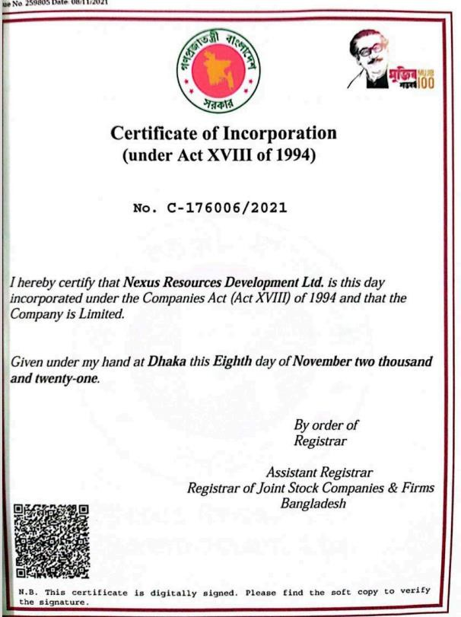

13

**VAT certificate & BIN of NRD ltd**

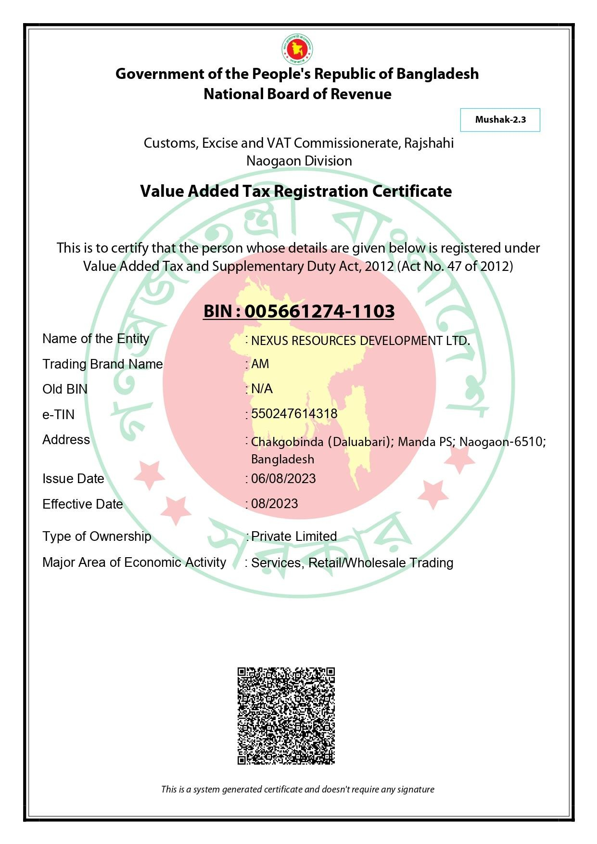

**Income Tax certificate of Nexus Resources Development Ltd**

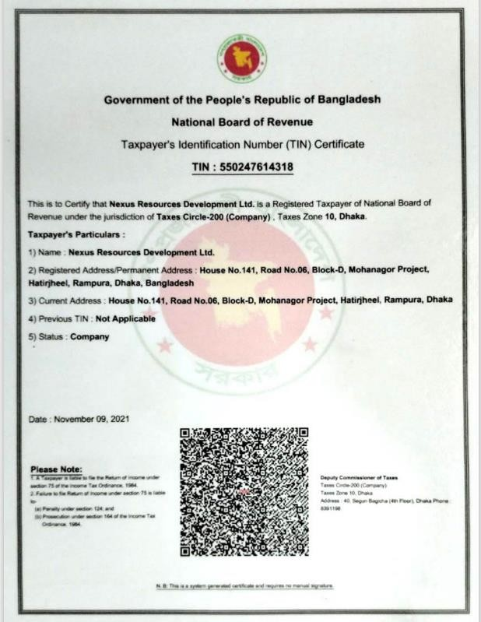

**Bank Solvency Certificat**

